

|  |
| --- |
|  |
|  |
| 2019 |



ZAIN EL-MASRI

# Table of contents

Table of contents 2

Design Brief: 3

A brief outline of what we are intended to do 3

Area of Investigation 4

Evidence of research 4

Design Sketches and final concept design 6

Hand sketched concept designs of the website & logo with feedback 6

6

8

Design changes 9

Identify variations between your final concept design and final product. Explain why these changes were made and how they impacted the final product. 1-2 pages 9

Evaluation 10

Describe good and bad features of your final product with reference to your research. Identify improvements that could be made to your design. 10

Bibliography 11

# Design Brief:

|  |
| --- |
| A brief outline of what we are intended to do Flynn's Arcade has been slowly losing money as the trend for accessing video games has moved away from social 'video game arcades' to at home 'video game consoles' such as the Atari & Commodore 64. Flynn wants to reposition his business as a venue for selling new games and trading used games. Flynn wants you to design and create ‘alpha phase’ website that communicates his new business model. |
| More information on Flynn’s Arcade: (<http://tron.wikia.com/wiki/Flynn's_Arcade>) |
| Related image­ |

# Area of Investigation

# Evidence of research

Comparison of website creation tools (IDE, CMS, Drag and Drop)

|  |  |  |  |
| --- | --- | --- | --- |
| Image result for notepad++ logo | Related imagegf | Image result for wix logo | Image result for dreamweaver logo |
| Notepad++ is a text and source code editor used on Microsoft windows. It is one of the most useful software’s when it comes to coding websites exactly how you want them.  It has been downloaded over 28 million times all around the globe. | With more than 50m websites built Weebly is one of the largest website builders. Weebly is specifically focused on online shopping it also has a very clear interface and is for less professional web creations. | Wix is it allows users to create HTML5 websites and mobile sites using online drag and drop tools, it is also used to create small websites. | Dreamweaver is a software for creating and designing web pages created by adobe, Dreamweaver is the most complete toolset for professional website designers. |

|  |  |  |  |  |
| --- | --- | --- | --- | --- |
| Price | Free of charge | From $15/mo | From $10/mo | From $29.99/mo |
| Features |  |  |  |  |
| Released | 2003 | 2006 | 2006 | 1997 |

What is Drag and drop, IDE, and CMS?

Drag and drop is a functionality by which users can select an object or a section of text and can move it to a desired location and "drop" it there. Using the drag and drop method is intended to be simple for users to move or copy items

An integrated development environment (IDE) is a software suite that combines basic tools required to write and test software.

A content management system (CMS) is a software application or set of related programs that are used to create and manage digital content.

Overall these are all factors of the website making companies, making several stuff really easy for their customers, as easy as dragging a button that normally takes at least 10 minutes to code.

Flynn and his design aesthetic

Firstly, who is Kevin Flynn?

Kevin Flynn was a gifted computer programmer, Flynn created TRON, an arcade game based on his experience inside the computer world alongside the TRON program, and made ENCOM the largest video game company in the world…

Flynn’s design aesthetic is kind of influenced by the 70s and 80s along with a very futuristic design

Data communications and its implications for web design

**Data communication** refers to the exchange of data between a source and a receiver via form of transmission media such as a wire cable. Data communication is said to be local if communicating devices are in the same building or a similarly restricted geographical area.

# Design Sketches and final concept design

# Hand sketched concept designs of the website & logo with feedback

# 

After a lot of thinking and designing I drew these two logos and asked my classmates for feedback on which one they preferred and what I could improve, they said:

|  |
| --- |
| “I really like the one on the right I just think that the font should be thicker”  “I like the one on the left because the packman and ghost replacing the c and a”  “I like the left one better but nearly everyone’s logo has a controller on it, so I’ll go with the one on the right”  “I like the one on the left, it looks cool” |

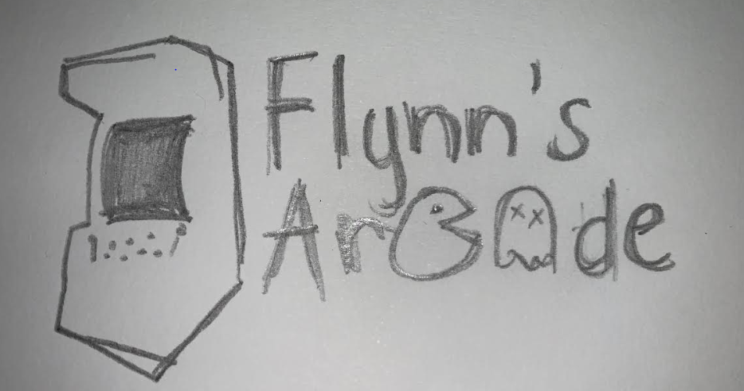 I then thought to myself how about if I changed the controller into something else? I was looking through the icons under gaming, and then I saw an arcade machine, so I drew an example to see how it looks:

I really liked it so I decided to use it….

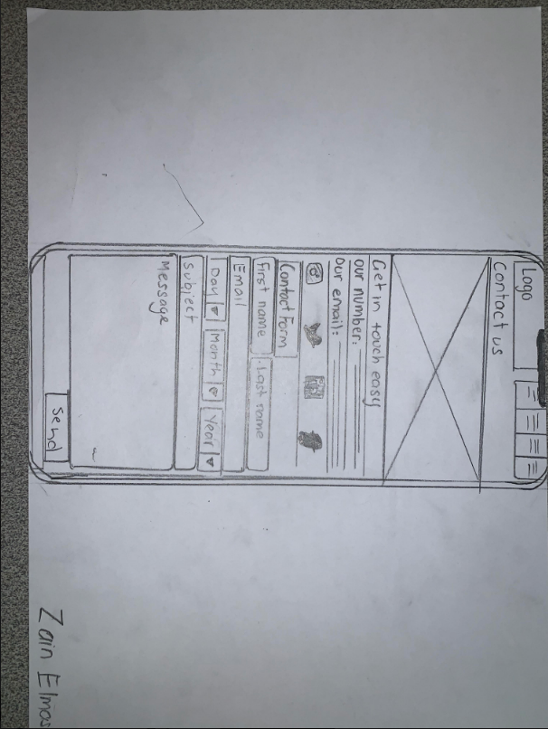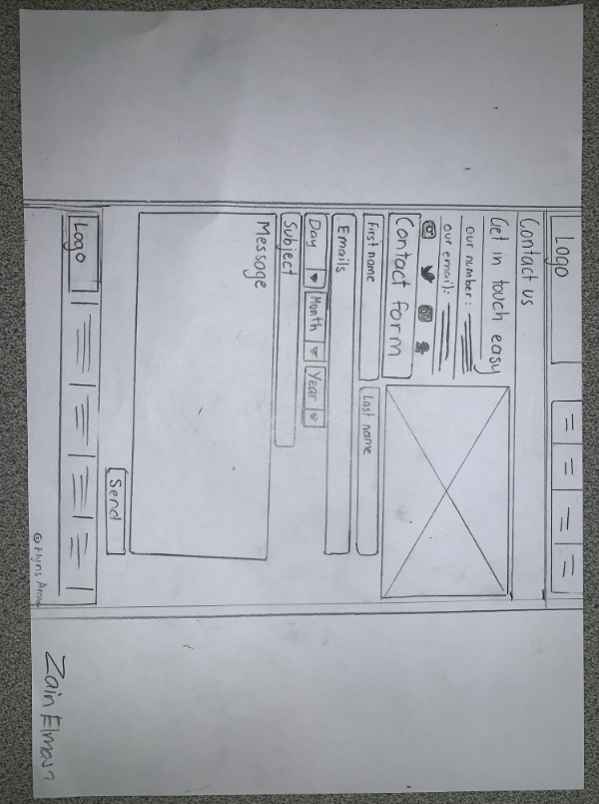

These are my website design sketches of how my websites contact page will look they are all inspired by the JB-HI-FI website, the first one is from a desktop screen and the second one is from a phone screen some of the feedback I got was:

|  |
| --- |
| “It looks very neat, and has great formatting”  “Very detailed” |

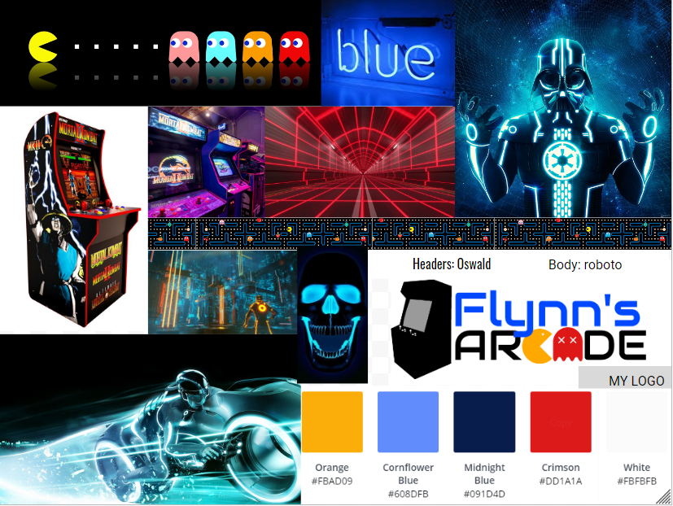My Mood Board

I wanted my mood board to be unique and to have cool colours, my moodboard was deeply inspired by the 80s retro kind of pacman aesthetic, at the same time of being in the neon, innovative, technologically advanced, Tron world.

# Design changes

# Identify variations between your final concept design and final product. Explain why these changes were made and how they impacted the final product. 1-2 pages

# Evaluation

# Describe good and bad features of your final product with reference to your research. Identify improvements that could be made to your design.

# 

# Bibliography

Acknowledge ALL resources used. Web pages, Images, Books, Video’s, etc.:

<https://en.wikipedia.org/wiki/Wix.com>

<https://www.computerhope.com/jargon/d/dreamweaver.htm>

<https://www.hostingadvice.com/how-to/what-is-wix/>

<https://www.websitetooltester.com/en/blog/wix-vs-weebly/>

<https://www.techopedia.com/definition/6918/drag-and-drop>

<https://tron.fandom.com/wiki/Kevin_Flynn>

<https://www.youtube.com/watch?v=pDsta8UgWEI>

<https://www.wix.com/upgrade/website>

<https://en.wikipedia.org/wiki/Adobe_Dreamweaver>

<https://www.codecademy.com/articles/what-is-an-ide>

<https://disney.fandom.com/wiki/Kevin_Flynn>

<https://getbootstrap.com/docs/4.3/layout/overview/>